
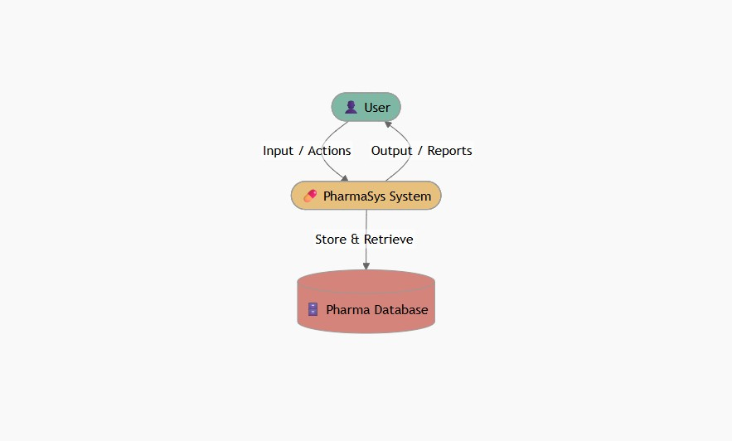
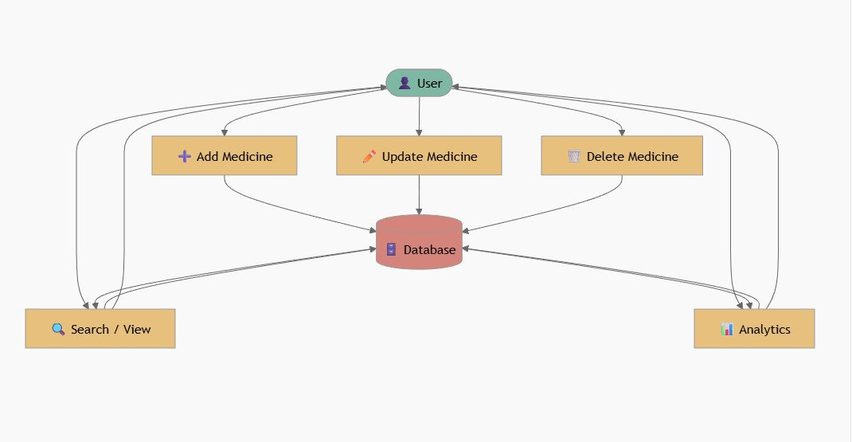
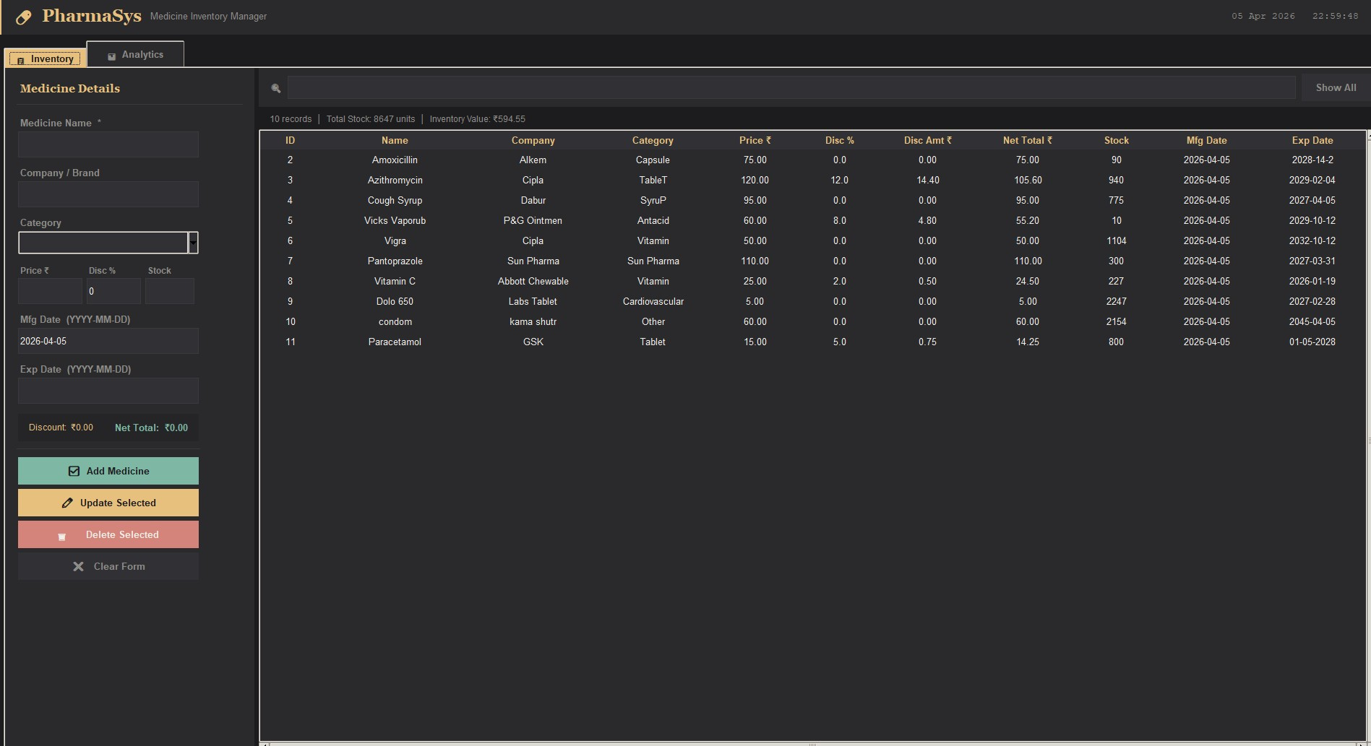
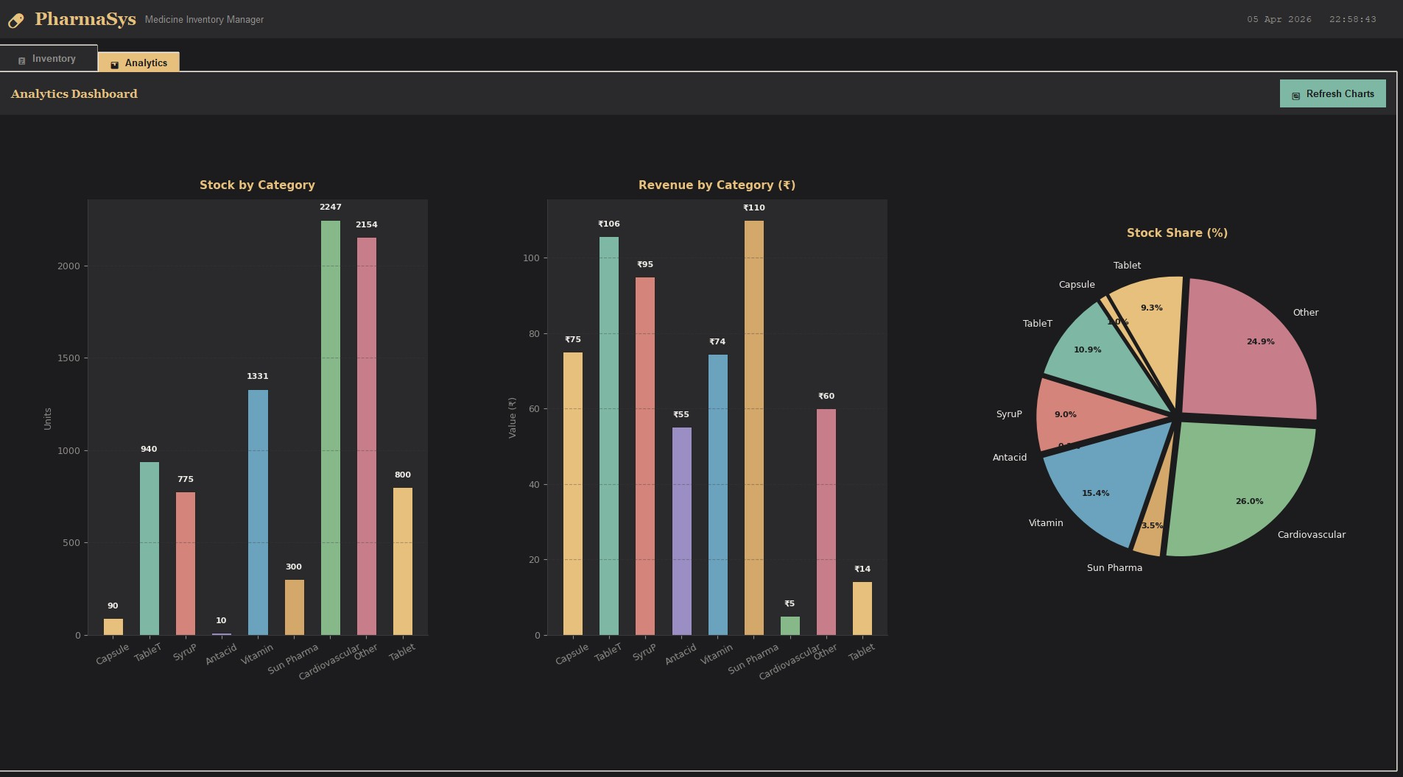
A Project Report On

Pharmacy Medicine Inventory Manager
Submittedin partial fulfillment of the requirement for the
BCA Semester-4 Python Programming Subject Final Examination.

BACHELOR OF COMPUTER APPLICATIONS
(B.C.A.)

Academic Year 2025 – 26

RISHI JADAV– (92400527021)

Internal Guide
PROF. AMIT GOHEL

Rajkot-Morbi Road, At & PO : Gauridad, Rajkot 360003. Gujarat. India.

CONTENTS
Chapters | Particulars | Page No.
1 | SYNOPSIS
2 | PREAMBLE
2.1 | General Introduction
2.2 | Statement of Problem
2.3 | Objective and Scope of the Study
2.4 | Module Description with Functionality
3 | SYSTEM DESIGN AND DEVELOPMENT
3.1 | Data Flow Diagram (DFD)
3.2 | Table Structure
3.3 | Menu Design
3.4 | Screen Design (Screenshots with Description)
4 | CONCLUSION
5 | LEARNING DURING PROJECT WORK
6 | BIBLIOGRAPHY
6.1 | Online References
6.2 | Offline References

FIGURE INDEX
Sr. No. | Figure No. | Particulars | Page No.
1 | 3.4.1 | Medicine Inventory Screen
2 | 3.4.2 | Analytics Dashboard Screen

TABLE INDEX
Sr. No. | Table No. | Particulars | Page No.
1 | 3.2.1 | medicines Table Structure
2 | 3.2.2 | Module Description Table

1. SYNOPSIS
- PharmaSys is a desktop application developed in Python using the Tkinter GUI library. It is designed to manage pharmacy medicine inventory with full CRUD (Create, Read, Update, Delete) operations, discount calculation, and visual analytics.

2. PREAMBLE

2.1 General Introduction
- Inventory management is a critical function for any pharmacy. Tracking medicine names, companies, categories, prices, discounts, stock levels, and expiry dates manually is time-consuming and error-prone.

2.2 Statement of Problem
Traditional pharmacy inventory management faces several challenges:

- Paper registers are prone to errors, loss, and tampering, leading to inaccurate stock records.
- Manual calculation of discounts and net totals is slow and error-prone for pharmacy staff.
- Tracking medicine expiry dates manually across hundreds of items is difficult and risky.
- There is no easy way to visualize stock levels and revenue by medicine category.

2.3 Objective and Scope of the Study
- To develop a desktop application for complete pharmacy inventory management using Python and Tkinter.
- To provide real-time discount and net total calculation when adding or updating medicines.
- To enable fast search and filter across all medicine records by name, company, or category.
- To generate visual bar charts and pie chart analytics for stock and revenue by category.

2.4 Module Description with Functionality

Module | Description | Key Functions
Database Layer | SQLite CRUD operations for medicine records | db_add, db_update, db_delete, db_all, db_search
Inventory Form | Input form for medicine details with live price preview | Add, Update, Delete, Clear Form
Inventory Table | Sortable, searchable Treeview with all records | Search, Show All, Sort columns, Select row
Analytics Charts | Matplotlib bar charts + pie chart per category | Stock by Category, Revenue by Category, Stock Share %
Header & Clock | App branding with live date-time display | Real-time clock tick every second

3. SYSTEM DESIGN AND DEVELOPMENT

3.1 Data Flow Diagram (DFD)

Level 0 – Context Diagram
The Pharmacy Staff (User) interacts with the PharmaSys application. The system reads from and writes to the SQLite database (pharma_data.db).

Level 1 – Main Processes
Three main processes handle all system functionality:

3.3 Menu Design
The application uses a tab-based navigation structure with two main tabs:

Tab | Panel / Section | Controls Available
📋 Inventory | Left Panel (Form) | Medicine Name, Company, Category, Price, Disc%, Stock, Mfg Date, Exp Date, Add / Update / Delete / Clear buttons
📋 Inventory | Right Panel (Table) | Search bar, Show All, Sortable Treeview with 11 columns, Stats bar
📊 Analytics | Charts Dashboard | Stock by Category (Bar), Revenue by Category (Bar), Stock Share % (Pie), Refresh Charts button

3.4 Screen Design (Screenshots with Short Description)

3.4.1 Medicine Inventory Screen

Figure 3.4.1: Medicine Details & Inventory Table Screen

3.4.2 Analytics Dashboard Screen

Figure 3.4.2: Analytics Dashboard – Charts Screen

4.CONCLUSION
- PharmaSys successfully achieves its goal of replacing manual pharmacy inventory tracking with an efficient, user-friendly digital solution. By integrating a form-based inventory panel with a sortable data table and live pricing calculations, the system covers all day-to-day pharmacy management needs.

5. LEARNING DURING PROJECT WORK

- Python OOP: Structured the application into a single App class with clearly separated methods for database operations, UI layout, business logic, and chart rendering — enforcing separation of concerns.

6. BIBLIOGRAPHY

6.1 Online References
- Official Python Documentation – https://docs.python.org/3/
- Tkinter GUI Library Reference – https://docs.python.org/3/library/tkinter.html
- SQLite3 Python Module – https://docs.python.org/3/library/sqlite3.html

6.2 Offline References
- Python Programming textbooks and class notes provided by the department.
- Study materials and lectures provided by Prof. Jitesh Solanki.

